РГПУ им. А.И. Герцена

Тема «Основные понятия теории графов»

Иванов Д.В., 2ИВТ, 1 группа, 2 подгруппа

***Задача 1***

Составить матрицы инцидентности и смежности для следующего графа:

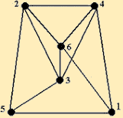

***Решение***

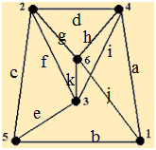

Матрица инцидентности:

|  |  |  |  |  |  |  |  |  |  |  |  |
| --- | --- | --- | --- | --- | --- | --- | --- | --- | --- | --- | --- |
|  | a | b | c | d | e | f | g | h | i | j | k |
| 1 | 1 | 1 | 0 | 0 | 0 | 0 | 0 | 0 | 0 | 1 | 0 |
| 2 | 0 | 0 | 1 | 1 | 0 | 1 | 1 | 0 | 0 | 0 | 0 |
| 3 | 0 | 0 | 0 | 0 | 1 | 1 | 0 | 0 | 1 | 0 | 1 |
| 4 | 1 | 0 | 0 | 1 | 0 | 0 | 0 | 1 | 1 | 0 | 0 |
| 5 | 0 | 1 | 1 | 0 | 1 | 0 | 0 | 0 | 0 | 0 | 0 |
| 6 | 0 | 0 | 0 | 0 | 0 | 0 | 1 | 1 | 0 | 1 | 1 |

Матрица смежности:

|  |  |  |  |  |  |  |
| --- | --- | --- | --- | --- | --- | --- |
|  | 1 | 2 | 3 | 4 | 5 | 6 |
| 1 | 0 | 0 | 0 | 1 | 1 | 1 |
| 2 | 0 | 0 | 1 | 1 | 1 | 1 |
| 3 | 0 | 1 | 0 | 1 | 1 | 1 |
| 4 | 1 | 1 | 1 | 0 | 0 | 1 |
| 5 | 1 | 1 | 1 | 0 | 0 | 0 |
| 6 | 1 | 1 | 1 | 1 | 0 | 0 |

***Задача 2***

Составить матрицы инцидентности и смежности для следующего графа:

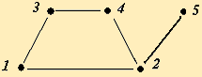

***Решение***

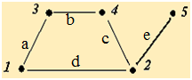

Матрица инцидентности:

|  |  |  |  |  |  |
| --- | --- | --- | --- | --- | --- |
|  | a | b | c | d | e |
| 1 | 1 | 0 | 0 | 1 | 0 |
| 2 | 0 | 0 | 1 | 1 | 1 |
| 3 | 1 | 1 | 0 | 0 | 0 |
| 4 | 0 | 1 | 1 | 0 | 0 |
| 5 | 0 | 0 | 0 | 0 | 1 |

Матрица смежности:

|  |  |  |  |  |  |
| --- | --- | --- | --- | --- | --- |
|  | 1 | 2 | 3 | 4 | 5 |
| 1 | 0 | 1 | 1 | 0 | 0 |
| 2 | 1 | 0 | 0 | 1 | 1 |
| 3 | 1 | 0 | 0 | 1 | 0 |
| 4 | 0 | 1 | 1 | 0 | 0 |
| 5 | 0 | 1 | 0 | 0 | 0 |

***Задача 3***

Составить матрицы инцидентности и смежности для следующего графа:

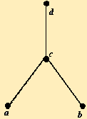

***Решение***

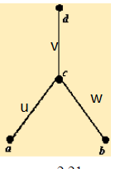

Матрица инцидентности:

|  |  |  |  |
| --- | --- | --- | --- |
|  | u | v | w |
| a | 1 | 0 | 0 |
| b | 0 | 0 | 1 |
| c | 1 | 1 | 1 |
| d | 0 | 1 | 0 |

Матрица смежности:

|  |  |  |  |  |
| --- | --- | --- | --- | --- |
|  | a | b | c | d |
| a | 0 | 0 | 1 | 0 |
| b | 0 | 0 | 1 | 0 |
| c | 1 | 1 | 0 | 1 |
| d | 0 | 0 | 1 | 0 |

***Задача 4***

Составить матрицы инцидентности и смежности для следующего графа:

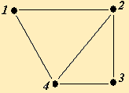

***Решение***

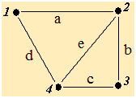

Матрица инцидентности:

|  |  |  |  |  |  |
| --- | --- | --- | --- | --- | --- |
|  | a | b | c | d | e |
| 1 | 1 | 0 | 0 | 1 | 0 |
| 2 | 1 | 1 | 0 | 0 | 1 |
| 3 | 0 | 1 | 1 | 0 | 0 |
| 4 | 0 | 0 | 1 | 1 | 1 |

Матрица смежности:

|  |  |  |  |  |
| --- | --- | --- | --- | --- |
|  | 1 | 2 | 3 | 4 |
| 1 | 0 | 1 | 0 | 1 |
| 2 | 1 | 0 | 1 | 1 |
| 3 | 0 | 1 | 0 | 1 |
| 4 | 1 | 1 | 1 | 0 |

***Задача 5***

Составить матрицы инцидентности и смежности для следующего графа:

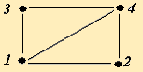

***Решение***

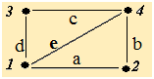

Матрица инцидентности:

|  |  |  |  |  |  |
| --- | --- | --- | --- | --- | --- |
|  | a | b | c | d | e |
| 1 | 1 | 0 | 0 | 1 | 1 |
| 2 | 1 | 1 | 0 | 0 | 0 |
| 3 | 0 | 0 | 1 | 1 | 0 |
| 4 | 0 | 1 | 1 | 0 | 1 |

Матрица смежности:

|  |  |  |  |  |
| --- | --- | --- | --- | --- |
|  | 1 | 2 | 3 | 4 |
| 1 | 0 | 1 | 1 | 1 |
| 2 | 1 | 0 | 0 | 1 |
| 3 | 1 | 0 | 0 | 1 |
| 4 | 1 | 1 | 1 | 0 |